Practical No 27

VIII. Resources required (Additional)
→ If any web resources required.

Resources used (Additional)
https://www.tutorialspoint.com/vb.net/vb.net

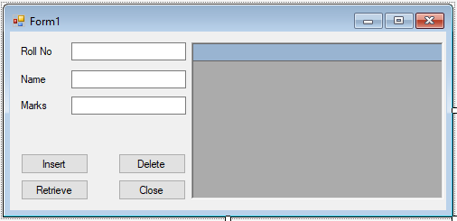Program Code
  - Write a program to insert the data & retrieve the data from database.
➢

Imports System.Data.OleDb Public Class Form1
Dim con As OleDbConnection

Dim ds As New DataSet
Dim cmd As OleDbCommand Dim da As OleDbDataAdapter

Private Sub Button1_Click(sender As Object, e As EventArgs) Handles Button1.Click Dim con As New OleDbConnection("Provider=Microsoft.Jet.OLEDB.4.0;Data
Source=C:\Users\Suresh\Documents\Visual Studio 2012\Projects\Insert and Retrieve\db1.mdb")
con.Open()
Dim InsertString As String
InsertString = "Insert into student(RollNo, Name, Marks) values('" + txtRollNo.Text + "','" + txtName.Text + "' ,'" + txtMarks.Text + "')"
Dim cmd As New OleDbCommand(InsertString, con) cmd.ExecuteNonQuery()
MsgBox(" Record Successfully Inserted") con.Close()
End Sub

Private Sub Button3_Click(sender As Object, e As EventArgs) Handles Button3.Click Dim con As New OleDbConnection("Provider=Microsoft.Jet.OLEDB.4.0;Data
Source=C:\Users\Suresh\Documents\Visual Studio 2012\Projects\Insert and Retrieve\db1.mdb")
con.Open()
Dim cmd As New OleDbCommand("Select * From student", con)

Dim da As New OleDbDataAdapter(cmd) DataGrid1.CaptionText = "Student Marks" da.Fill(ds, "student") DataGrid1.DataSource = ds DataGrid1.DataMember = "student" con.Close()
End Sub

Private Sub Button2_Click(sender As Object, e As EventArgs) Handles Button2.Click
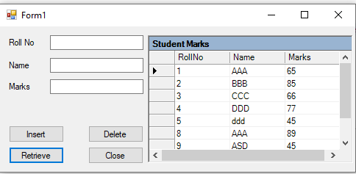
Dim con As New OleDbConnection("Provider=Microsoft.Jet.OLEDB.4.0;Data
Source=C:\Users\Suresh\Documents\Visual Studio 2012\Projects\Insert and Retrieve\db1.mdb")
con.Open()
Dim DeleteString As String
DeleteString = "Delete From student where RollNo ='" + txtRollNo.Text + "'" Dim cmd As New OleDbCommand(DeleteString, con) cmd.ExecuteNonQuery()
MsgBox(" Record Successfully Deleted") con.Close()
End Sub

Private Sub Button4_Click(sender As Object, e As EventArgs) Handles Button4.Click Close()
End Sub End Class

Output:
- Practical related Questions
  - Write syntax of command object execute method.
➢
    - ExecuteScaler():
dr = cmd.ExecuteScaler();
    - ExecuteReader():
dr = cmd.ExecuteReader();
    - ExecuteNonQuery():
dr = cmd.ExecuteNonQuery();

ercise
  - Design a simple Windowsform for accepting the details of Employee. Using the connected architecture of ADO.NET, perform the following operations:
    - Insert Record
    - Search Record
    - Update Record
    - Delete Record
➢

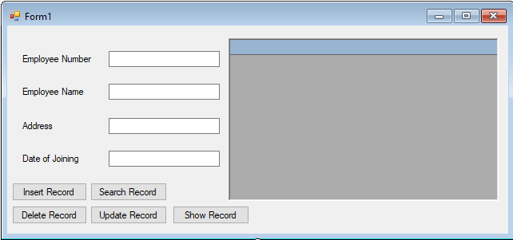Imports System.Data.OleDb Public Class Form1
Dim con As OleDbConnection Dim ds As New DataSet
Dim cmd As OleDbCommand Dim da As OleDbDataAdapter
Private Sub btnIns_Click(sender As Object, e As EventArgs) Handles btnIns.Click Dim con As New OleDbConnection("Provider=Microsoft.Jet.OLEDB.4.0;Data
Source=C:\Users\Suresh\Documents\Visual Studio 2012\Projects\Employee\Employee.mdb")
con.Open()
If txtNo.Text = "" Then
MsgBox("Please Enter Employee Number") Else
Dim InsertString As String
InsertString = "Insert into Employee(Emp_No, Emp_Name, Address, Date_of_joining) values('" + txtNo.Text + "','" + txtName.Text + "' ,'" + txtAdd.Text + "','"
+ txtDOJ.Text + "')"
Dim cmd As New OleDbCommand(InsertString, con) cmd.ExecuteNonQuery()
MsgBox(" Record Successfully Inserted") txtNo.Clear()
txtName.Clear() txtAdd.Clear() txtDOJ.Clear()

con.Close() End If
End Sub

Private Sub btnDel_Click(sender As Object, e As EventArgs) Handles btnDel.Click Dim con As New OleDbConnection("Provider=Microsoft.Jet.OLEDB.4.0;Data
Source=C:\Users\Suresh\Documents\Visual Studio 2012\Projects\Employee\Employee.mdb")
con.Open()
If txtNo.Text = "" Then
MsgBox("Please Enter Employee Number") Else
Dim DeleteString As String
DeleteString = "Delete From Employee where Emp_No ='" + txtNo.Text + "'" Dim cmd As New OleDbCommand(DeleteString, con) cmd.ExecuteNonQuery()
MsgBox(" Record Successfully Deleted") txtNo.Clear()
txtNo.Focus() con.Close()
End If End Sub
Private Sub btnUpd_Click(sender As Object, e As EventArgs) Handles btnUpd.Click Dim con As New OleDbConnection("Provider=Microsoft.Jet.OLEDB.4.0;Data
Source=C:\Users\Suresh\Documents\Visual Studio 2012\Projects\Employee\Employee.mdb")
con.Open()
If txtNo.Text <> "" Then
Dim UpdateString As String
UpdateString = "Update Employee SET Emp_No ='" + txtNo.Text + "',Emp_Name='" + txtName.Text + "',Address='" + txtAdd.Text + "',Date_of_joining='" + txtDOJ.Text + "' Where Emp_No ='" + txtNo.Text + "'"
Dim cmd As New OleDbCommand(UpdateString, con) cmd.ExecuteNonQuery()
MsgBox(" Record Successfully Updated") txtNo.Clear()
txtName.Clear() txtAdd.Clear() txtDOJ.Clear() con.Close()
Else
MsgBox(" Please Enter Employment Number") End If
End Sub

Private Sub btnShow_Click(sender As Object, e As EventArgs) Handles btnShow.Click Dim con As New OleDbConnection("Provider=Microsoft.Jet.OLEDB.4.0;Data
Source=C:\Users\Suresh\Documents\Visual Studio 2012\Projects\Employee\Employee.mdb")
con.Open()
Dim cmd As New OleDbCommand("Select * From Employee", con) Dim da As New OleDbDataAdapter(cmd)
Dim ds As New DataSet DataGrid1.CaptionText = "Employee Record" da.Fill(ds, "Employee")

DataGrid1.DataSource = ds DataGrid1.DataMember = "Employee" con.Close()
End Sub

Private Sub btnSearch_Click(sender As Object, e As EventArgs) Handles btnSearch.Click
If txtNo.Text = "" Then
MsgBox("Please Enter Employee Number")

Else
Dim con As New OleDbConnection("Provider=Microsoft.Jet.OLEDB.4.0;Data Source=C:\Users\Suresh\Documents\Visual Studio 2012\Projects\Employee\Employee.mdb")
con.Open()
Dim cmd As New OleDbCommand("Select * From Employee where Emp_No like '" + txtNo.Text + "'", con)
Dim da As New OleDbDataAdapter(cmd) Dim ds As New DataSet DataGrid1.CaptionText = "Employee Record" da.Fill(ds, "Employee")
DataGrid1.DataSource = ds.Tables("Employee") da.Dispose()
con.Close() txtNo.Clear() txtNo.Focus()
End If End Sub
End Class

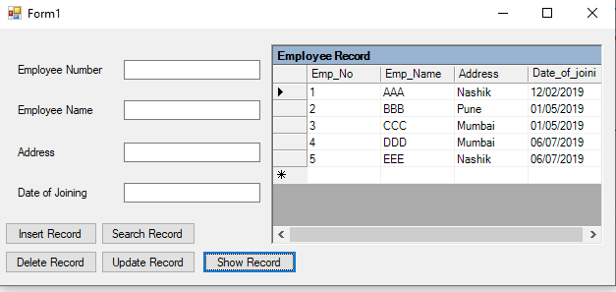
OUTPUT:

